Detecting Forest Fires using Machine Learning models and conducting predictive analysis employing Mathematical models.



By

**Azra Nisar**

In partial fulfilment of the requirement for the degree

Bachelor of Science in Computer Science

Department of Computer Science, School of Arts & Science

University of Central Asia, Naryn campus, Kyrgyz republic

(2024)

**DECLARATION BY AUTHOR**

I/we certify that this work has not been accepted in substance for any degree and is not concurrently being submitted for any degree other than that of Bachelor of Science in Computer Science being studied at the Department of Computer Science, School of Arts & Science, University of Central Asia, Kyrgyz Republic. I/we also declare that this work is the result of my/our own findings and investigations except where otherwise identified by references and that I/we have not plagiarized another’s work.A close-up of a signature

Azra Nisar

**DECLARATION BY SUPERVISOR**

I, the undersigned hereby certify that I have read this project report and finally approve it with recommendation that this report may be submitted by the authors above to the final year project evaluation committee for final evaluation and presentation, in partial fulfillment of the requirements for the degree of Bachelor of Science in Computer Science at the Department of Computer Science, School of Arts & Sciences, University of Central Asia, Kyrgyz Republic.



Dr. Muhammad Fayaz

ABSTRACT 7

CHAPTER 1. INTRODUCTION 9

1.1 Aims and Objectives 9

1.2. Business benefits of the project 10

CHAPTER 2. LITERATURE REVIEW 12

CHAPTER 3. PROPOSED MODEL 15

3.1 Data Acquisition, and Preprocessing 16

3.1.1 Understanding the dataset. 16

3.1.2 Data Preprocessing 16

3.1.3 Feature Extraction 16

Loading Images 18

Image resizing 18

Data Augmentation 18

Data labeling and encoding 18

Splitting data into testing and training 19

3.2 Model selection and training 19

*3.2.1 Selecting a model.* 19

*3.2.2 Model Training* 19

3.3 Standardization 19

*3.4.1 Convolution Neural Network* 20

*3.4.2 Random Forest Tree* 21

*3.4.3 Support Vector Machine* 22

*3.4.4 ARIMA (MATHEMATICAL MODEL)* 22

3.5 Application Module 23

CHAPTER 4. IMPLEMENTATION, RESULTS, AND DISCUSSION 24

4.1 Implementation Setup 24

4.1. Dataset 25

4.2. Results 25

4.2.1 Results and Discussions for Random Forest Algorithm 26

4.2.2 Results and Discussions for Support Vector Machine 28

4.2.3. Results and Discussions for CNN 30

4.2.4 Results and Discussions for Rothermel model 33

4.2.5 Results and Discussions for ARIMA model 33

CHAPTER 5. PERFORMANCE EVALUATION 33

CHAPTER 6. APPLICATION MODULE 35

6.1 Predictive analysis in R 38

6.2 Similar applications comparison table 40

6.2 Unique Features of my app 41

Conclusion 41

References 43

**List of Figures**

Figure 2 A conceptual model of proposed method 12

Figure 3 Detailed Processing Diagram of the Proposed Model 13

Figure 4 Detailed diagram for data preprocessing 14

Figure 5 Structural Diagram for feature extraction stage 15

Figure 6 Schematic diagram for CNN 18

Figure 7 Detailed diagram of Random forest tree 19

Figure 8 Schematic Diagram for SVM 19

Figure 9 Schematic diagram of ARIMA model 20

Figure 10 Illustration of web-application for prediction 21

Figure 13 Fire and No Fire prediction confusion matrix using Random Forest. 24

Figure 14 Accuracy of testing, training, and validation of random forest. 24

Figure 15 Performance evaluation of fire images (Random Forest) 25

Figure 16 Performance evaluation of no fire image (Random Forest) 25

Figure 17 Confusion matrix of SVM 26

Figure 18 Performance evaluation of SVM. 26

Figure 19 Performance evaluation of fire images (SVM) 27

Figure 20 Performance evaluation of no fire images (SVM) 27

Figure 21 Confusion matrix of CNN 28

Figure 22 Accuracy of testing, training, and validation in CNN 28

Figure 23 Performance evaluation for Binary CNN 29

Figure 24 Performance evaluation for no fire images 29

Figure 25 Rothermel equation 30

Figure 27 Graphical representation of evaluation metrices 31

Figure 28 Homepage of the web application 32

Figure 29 Dashboard page of the application 33

Figure 30 Result display after prediction 33

Figure 31 R Shinny dashboard 34

Figure 32 Detailed diagram of Rothermel model 34

Figure 33 3D visualization of Rothermel model results 35

**List of Tables**

Table 1.1 Notations with Descriptions 10

Table 4.1 Hardware and Software Specifications used in the proposed model implementations. 21

Table 4.1.1 Details of Parameters for each Classifier 22

Table 5.1 Evaluation metrices of RF, SVM, and CNN 31

Table 6.1 Similar app comparison table 37

# 

# 

# 

# 

# 

# 

# 

# 

# 

# ABSTRACT

The escalating incidence of forest fires poses a significant threat to ecosystems and contributes to the cycle of global warming. This project delves into the intricate relationship between forest fires and global warming, exploring how rising temperatures facilitate the spread of fires while the ensuing heat exacerbates climate change, creating a positive feedback loop. Human-induced fires, which spread twice as fast as natural fires and result in greater arboreal mortality, have exacerbated this issue, as evidenced by research from the University of Maryland highlighting a loss of three million more hectares of forest since 2001—an area equivalent to Belgium (Alkhatib, 2023). Furthermore, the environmental ramifications of forest fires extend beyond deforestation; the smoke emitted introduces noxious pollutants such as ozone, NO2, PM2.5, and hydrocarbons into the atmosphere, significantly contributing to air pollution and global warming.

This research seeks to offer a comprehensive analysis of forest fire patterns and the detection of their occurrences through advanced machine learning techniques. By predicting forest fires with dynamic mathematical models, the project aims to equip authorities and stakeholders with tools for better forest management and mitigation strategies. In addressing this critical issue, the project stands to benefit not just specific regions, but global communities, underscoring the universal impact of wildfires and the collective responsibility in combating them.

Richard C. Rothermel introduced his groundbreaking fire spread rate model in 1972 which is recognized as the universal model to predict wildfire behavior (firelab, 2023). Rothermel's model was developed during the 1960s and 1970s at the Missoula Fire Sciences Laboratory. Known as the "Rothermel Model," it forms the basis of numerous digital fire behavior analysis systems, which are integral to fire management, training, and operational forecasting. In the initial stages of its development, the groundbreaking Rothermel Model was seen as having a broad spectrum of potential applications. These included predicting fire behavior on a localized scale, simulating wildfires on a large scale, and strategizing for fuel treatments and controlled burns (firelab, 2023). Over the following decades, these envisioned uses, among others, have been realized and integrated into practical operations.

***Keywords: Machine learning, forest fire, user interface, dataset, mathematical models, ARIMA, Rothermel model***

**Acknowledgment**

Throughout the final year project, I have received huge support and assistance. I would first like to thank my supervisor, Dr. Muhammad Fayaz, whose expertise were invaluable from the step of formulating the research topic to the end of this great work. Your insightful and experienced feedback and support pushed me to sharpen my understanding as well as the perfect culmination of this research.

Other than that, I would also want to extend my utmost gratitude to all the Computer Science Department staff, especially our department head Dr. Ayman Aljarbouh for helping us in every possible way to complete our work without any administrative hurdles.

Lastly, I would also like to take this opportunity to express my gratitude and love for my parents for their unwavering support during all the challenges I faced relevant to the given thesis.

# 

# 

# CHAPTER 1. INTRODUCTION

Forest fire is a burning fire in an area covered with trees which is challenging to control and spreads at a fast pace (Cambridge reference, n.d.). Global warming and forest fire are profoundly interconnected. For instance, global warming results in forest fire due to the rising temperature and the heat of forest fire eventually contributes to global warming. Therefore, their relationship forms a positive feedback loop. Apart from global warming, human activities are equally responsible for forest fire. According to University of California’s fire ecologist fires sparked due to human activities are more extreme because they spread faster and kills a greater number of trees than the ones caused by lightning or nature (Joosse, 2020). For instance, human prone fires spread at a speed of 1.8km per day which is twice as fast as lightning induced fires. The number of forest fire has increased drastically in the past few years and its impacts have amused everyone indeed. According to a research study conducted by the university of Maryland, forest fires have resulted in a loss of three million more hectares of trees compared to 2001 which equals an area of roughly Belgium’s size (MacCarthy et al., 2023). It is not only the fire that leads to global problems, but wildfire smoke also has hazardous impacts on the environment. The smoke contains harmful air pollutants such as ozone, NO2, PM2.5, and hydrocarbons which results in air pollution eventually (WHO, n.d.). The carbon released from wildfires is a huge contributor to global warming and climate change.

Wildfires affect everyone equally regardless of where we live therefore, my research and project will address this respective global issue. The research will help in analyzing and finding trends in forest fires and detecting their occurrences using various machine learning techniques. Furthermore, this project aims to predict forest fires using dynamic mathematical models. I have used Rothermel model to find the spread rate of the forest fire and ARIMA (Autoregressive integrated moving average) model to conduct predictive analysis.

## 1.1 Aims and Objectives

* **Aims:**
  + This project aims at training a machine learning model on an image dataset collected from an online source which can recognize the fire in an image and developing an alert system to speed up the process of fire extinguishing, which can be enhanced and monetized and used by the fire extinguishing companies, by generating an alert that notifies the fire extinguishing companies.
* **Objectives:**
* Create an alert system in the form of web application or mobile app to notify the relevant personals about fire.
* Train a deep learning model for fire recognition to increase accuracy and decrease technical risks of misclassification.
* This project aims to acquire a minimum of 80% accuracy for the classification model.
* To employ classification models to classify fire, no fire, smoke, and no smoke images from the dataset.
* To use dynamic mathematical models to predict forest fires.

## 1.2. Business benefits of the project

The business benefits of the project focused on analyzing and predicting forest fires using machine learning and dynamic mathematical models are multifaceted, extending from economic gains to corporate social responsibility:

* *Risk management and management*

Businesses in sectors like insurance, agriculture, and real estate can significantly reduce risks and financial losses associated with forest fires by implementing predictive models that allow for better planning and quicker response.

* *Resource Allocation*

Efficiently predicting forest fires enables governments and firefighting units to optimally allocate resources, thus saving costs associated with emergency responses and reducing the economic impact of fires.

* *Benefits for the Insurance Industry*

For insurance companies, improved prediction models mean more accurate risk assessment, which can lead to more tailored insurance packages and premiums, potentially increasing profitability.

* *Real Estate and land value protection*

Real estate developers and investors can use insights from this project to protect their assets and invest in safer areas, preserving property values and investor confidence.

* *Tourism and recreation*

For businesses in the tourism sector, better management of forest fire risks can protect natural attractions and ensure the continuity of tourism revenues.

* *Regulatory Compliance*

For businesses with operations in fire-prone areas, advanced prediction capabilities can help in maintaining compliance with environmental regulations and avoiding fines or sanctions.

* *New markets and innovation*

Technology firms can utilize the findings to develop innovative products, such as early warning systems and firefighting drones, opening new markets and revenue streams.

Table 1.1 Notations with Descriptions

|  |  |
| --- | --- |
| **Notations** | **Explanations** |
| ROS | Rate of Spread |
| WHO | World Health organization |
| ML | Machine Learning |
| PM | Particulate Matters |
| RF | Random Forest |
| SVM | Support Vector Machine |
| CNN | Convolutional Neural Networks |
| ARIMA | Autoregressive Integrated moving average |
| SARIMA | Seasonal Autoregressive Integrated moving average |
|  |  |

The structure of the remaining report is given below. In Section 2 the literature review of different models for energy consumption prediction in smart homes has been done in detail. Section 3 presents the proposed model, the sub-modules, such as preprocessing, prediction, performance evaluation, interface have also been discussed in detail in this section. In Section 4 the implementation details and results are given. Section 5 presents the performance evaluation, and Section 6 represents the application module. In the last Section 7 the proposed work is concluded.

# 

# 

# 

# 

# 

# 

# 

# 

# 

# 

# 

# 

# 

# CHAPTER 2. LITERATURE REVIEW

Forests cover a wide range of area on earth, and with an increase in global warming and climate change forests conservation has become a major concern. Unfortunately, due to natural causes and human activities forest fires are increasing at a fast pace thus affecting the whole ecosystem. Uncontrollable flames caused an estimated 4,225,000 km2 of land to burn between 2002 and 2016 (Abdusalomov et al., 2023). Some of the main natural causes of forest fires are lightning, volcanos, dry weather, and wind while smoking and cooking are human activities that contribute to wildfires. Amusingly 90% of the forest fires are caused by human activities (Abdusalomov et al., 2023).

Machine learning techniques have been widely used in forest fire prediction and detection. Fire detection systems based on machine learning rely on manually extracting visible information from photos. These features solely focus on the superficial aspects of the flame, which may result in data loss when manually extracted. Deep learning algorithms, unlike machine learning algorithms, can automatically extract and learn complex feature representations (Sathishkumar et al., 2023).

CNNs have significantly improved performance in a variety of computer-based vision applications, including visual identification and image categorization. Many researchers have employed CNN (convolution neural network) based wildfires detection using unmanned aerial vehicle dataset (Sathishkumar et al., 2023). Convolutional Neural Networks (CNN) are a sort of Artificial Intelligence (AI) technique that has been demonstrated to perform better than cutting-edge approaches in image classification and other computer vision applications, but their training time may be prohibitive, furthermore, when there is an insufficient dataset, a pre-trained CNN may underperform (Seydi et al., 2022).

Most of the fire detection research have used YOLOv2 (you only look once) CNN for both outdoor and indoor fire scenarios. (YOLO) is a deep learning model for object detection; YOLOv2 is the next version that has been upgraded to address YOLO's shortcomings, namely the inability to accurately locate and mark the region of interest in images and the lower recall rate when compared to other region-oriented algorithms. Increasing the architecture's effectiveness as a result.

According to a research study, automatic fire detection can be classified into three types: aerial, ground, and borne detection. The ground-based systems use numerous gazing black and white video cameras in fire detection, which detect smoke and compare it to natural smoke (Rajan et al., 2022). The key advantage of employing this technology is the great temporal and spatial resolution, thus, making it easier to detect. However, these techniques still come with some demerits therefore, it is vital to use a mechanism which can detect the fire as early as possible.

Mathematical models have been useful to predict the spread rate of fire. There are mainly three types of mathematical models which include empirical, semi empirical, and theoretical models. Theoretical approaches to understanding fire dynamics involve applying the principles of combustion, fluid dynamics, and heat transfer. These approaches necessitate incorporating numerous parameters into the computational equations. The resulting equations are typically complex, complicating their practical application, particularly in real-world scenarios in developing nations. Furthermore, confirming the accuracy of these models is challenging, given the diverse and large-scale nature of wildland fires (firelab, 2023). Empirical models are built upon statistical correlations derived from observed data and past studies on wildland fires. Their application is generally confined to scenarios that closely resemble the tested conditions. Meanwhile, semi-empirical models combine basic physical principles with data obtained from experiments to enhance their applicability (firelab, 2023).

The Rothermel Model, renowned for its effectiveness both in practical scenarios and theoretical applications, remains a cornerstone in contemporary fire behavior modeling. Its integration into various advanced modeling techniques, including remote sensing, finite difference methods, finite element analysis, neural networks, and cellular automata, highlights its fundamental role. However, the model's complexity, characterized by the need for 24 distinct parameters, renders its implementation quite costly.

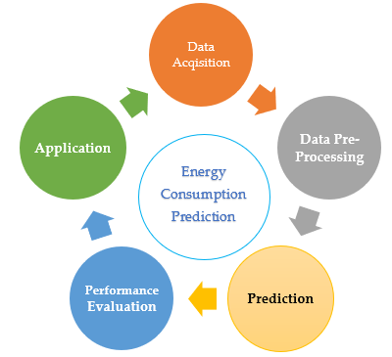

Forest Fire Prediction

Figure 2 A conceptual model of proposed method

# 

# CHAPTER 3. PROPOSED MODEL

* 1. *Iterative Method*

Flexibility in Project Evolution: The iterative approach enables you to seamlessly integrate new changes and insights at different stages of the project. This is especially valuable for a project that combines image datasets with predictive modeling due to its inherent complexity.

Progressive Testing and Enhancement: In this model, you can periodically evaluate the fire detection algorithms and their integration with the Rothermel Model. Each cycle provides an opportunity to enhance the model based on feedback and test outcomes.

Adaptability to New Developments: The iterative model is conducive to incorporating new datasets or adopting novel image processing and machine learning methodologies as they emerge, keeping your project up to date.

Step-by-Step Development: This approach allows you to concentrate on individual components of the project sequentially. For instance, you might initially focus on creating the fire detection algorithm, and thereafter work on integrating it with the Rothermel Model, refining each section progressively before advancing.

Figure 3 Detailed Processing Diagram of the Proposed Model

## 3.1 Data Acquisition, and Preprocessing

For my project I need to have a credible image dataset that I have extracted from Kaggle. I have used three separate image datasets and then combined them to one big dataset. My data collection and preprocessing process is given below.

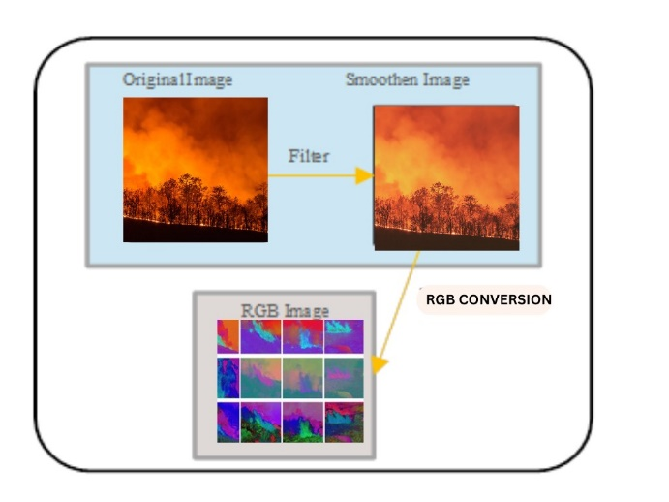

Figure 4 Detailed diagram for data preprocessing.

### 3.1.1 Understanding the dataset.

Reviewing and understanding any information or documentation attached with the dataset to deeply know the labels, source, content, and format of the respective data. Following that visualizing few samples images to get an idea of their quality. It is not necessary to have images of uniform sizes and same dimensions. Therefore, resizing is vital to ensure image consistency. And for that rescaling is required which can be done in Python.

### 3.1.2 Data Preprocessing

Data preprocessing is considered as one of the most vital initial stages of data mining because it converts rough data into a useable format. Data comes with many errors and inconsistencies; therefore, its preprocessing is crucial to make it clean and ready to use. A preprocessed data improves the accuracy, handles data imbalances, and transforms the data. For my project I have been using Python for data preprocessing.

### 3.1.3 Feature Extraction

One of the vital steps in image processing is to perform feature extraction. The images that are used in the dataset should go through some filtering and transformations before they are given to the models for classification or recognition. The feature extraction process involves transforming the raw data into numerical features still containing a reasonable amount of information from the original dataset of images. Some of the integral statistical moments include kurtosis, skewness, variance, and entropy that are extracted the corresponding files from each channel. These respective modes are significantly important for training the models efficiently and to improve their performance.

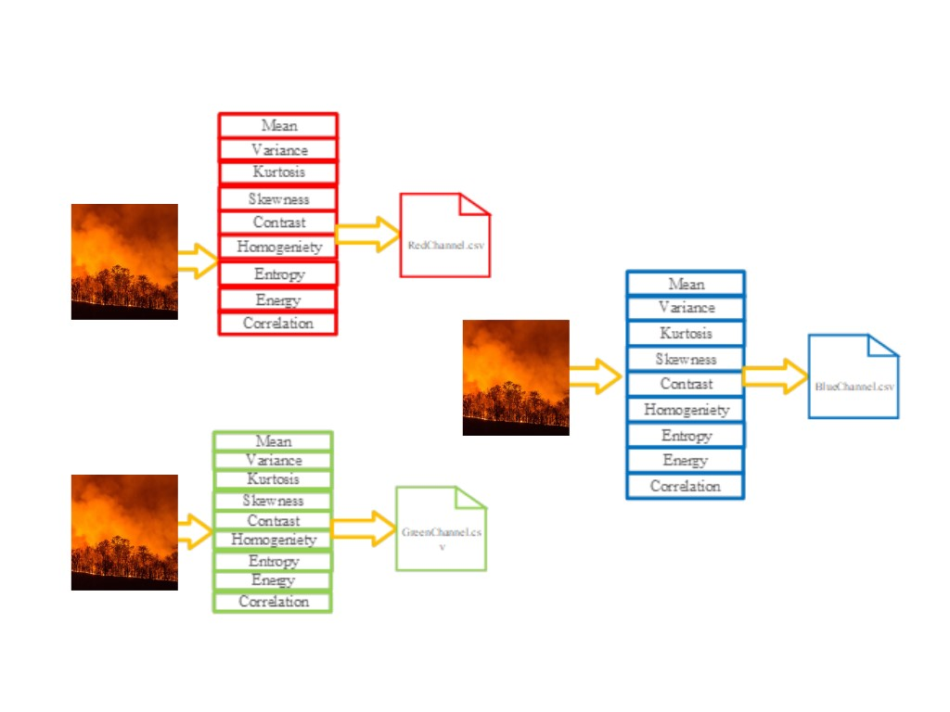

Figure 5 Structural Diagram for feature extraction stage

The Equation (4-7) gives the mean, variance, skewness, and kurtosis of the image.

|  |  |
| --- | --- |
| $$Mean= \frac{\sum_{i=1}^{n}{x}}{n}$$ | *(4)* |
| $$variance= \frac{\sum_{i=1}^{n}{{(x_{i}-x)}^{2}}}{n}$$ | *(5)* |
| $$Skewness \left(X\right)=\frac{\sum_{i=1}^{n}{{(x_{i}-\overline{x})}^{3}}}{n}$$ | *(6)* |
| $$Kurtosis \left(X\right)= \frac{\sum_{i=1}^{n}{{(x_{i}-\overline{x})}^{4}}}{n}$$ | *(7)* |

Where n is a total number of pixels in an image, x ̅ is a mean value of the image pixel values, and x is an image pixel value. Mean calculation is the first-order statistical analysis, and the value shows the image intensity with respect to all the pixels. The mean of the image is sensitive to its bright and dark values. Variance is the second-order statistical analysis, and its value shows image contrast. The skewness of the image is an asymmetrical measure, while kurtosis measures the peak and flatness of the pixel values from their normal distribution.

In equation (8-12) represents the mathematical forms of entropy, correlation, contrast, homogeneity, and energy respectively.

|  |  |
| --- | --- |
| $$Entropy =-\sum_{x}{\sum_{y}{λ_{i,j}}}\log_{2}λ_{i,j}$$ | *(8)* |
| $$Correlation = \frac{1}{σ_{α}σ_{β}}\sum_{x}{\sum_{y}{(x-{\overline{x}}_{α})((x-{\overline{x}}_{β})}}λ_{i,j}$$ | *(9)* |
| $$Contrast =\sum_{i}{\sum_{j}{{{(λ}_{i,j})}^{2}}} {(i-j)}^{2}$$ | *(10)* |
|  | *(11)* |
| $$Energy= \sum_{i}{\sum_{j}{{(λ_{i,j})}^{2}}}$$ | *(12)* |

### Loading Images

Python provides a variety of libraries such as scikit-image and OpenCV, which are efficient in loading images from their respective paths.

### Image resizing

For an image dataset, resizing is vital to get a consistent size for images. I am using Convolutional Neural Networks (CNN) which requires an input of a certain size.

### Data Augmentation

Data augmentation is one of the efficient ways to increase image dataset diversity by augmenting the data in multiple angles, rotations, flipping, and zooming. This results in higher model accuracy and gives good results.

### 

### Data labeling and encoding

Data labeling and encoding is a crucial part of data preprocessing. My dataset is binary, so I have labelled using 0 and 1 where 0 is labelled for fire and 1 for no fire images respectively.

### Splitting data into testing and training

To train a machine learning model efficiently it’s important to divide the data into training and testing. Training data is mostly 70-80% of the original data while the rest goes to the testing data.

### 3.2 **Model selection and training**

## *3.2.1 Selecting a model.*

Model selection is crucial for machine learning projects because they should give effective results based on their accuracy. Model selection is highly dependent on the type of dataset, for instance, some algorithms work well for image dataset while others don’t. I am dealing with images for my project, and it is binary classification, so I have chosen Convolution neural networks, Random Forest, and support vector machine.

## *3.2.2 Model Training*

The dataset contains 70-80% training dataset which is used to train the model. However, the accuracy is dependent on the dataset quality therefore, rescaling and augmenting the data is vital for a higher accuracy. Below are the models I have trained for my project.

# 3.3 Standardization

Standardization is a data preprocessing technique aimed at adjusting the dataset to ensure that its distribution has a mean value of 0 and a standard deviation of 1. This process modifies the original data values to align more closely with the dataset's mean. The formula for standardization is given as ***X_new = (X - μ) / σ,*** where X represents the feature's input value, μ is the mean of the feature, and σ is the feature's standard deviation. Following this procedure, two new datasets were generated: one normalized and the other standardized.

In the final phase of the data preprocessing module, data reduction was performed. This involved evaluating the input variables' correlation with the target variable to identify and retain only those features with a significant impact on the outcomes, discarding less influential ones. This step of reducing dimensions ensures that the machine learning model works with only the most relevant features, enhancing its efficiency and effectiveness.

3.4 Prediction

The last actual stage of the proposed model is prediction, in this stage we have used different machine learning algorithms for energy consumption prediction. Here, we will discuss some algorithms that may be used for prediction.

## *3.4.1 Convolution Neural Network*

Binary Classification is one of the vital machine learning tasks which classifies data into two categories or classes. Binary classification using convolution neural networks makes the classification process easier and faster. The below diagrams depict how Binary CNN works.

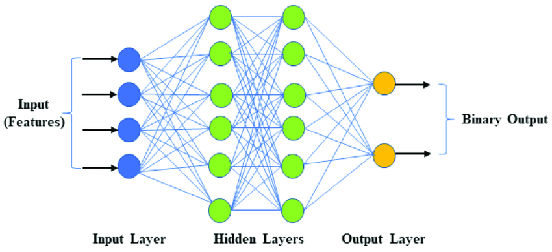

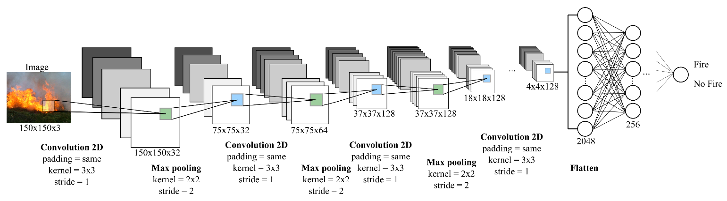

Figure 6 Schematic diagram for CNN

As showed in the Figure 6, to pass the data to hidden layer, the bias and weights should be summed. $φ\left(x\right)=\sum_{i=1}^{n}{w_{i }}*x_{i }+b$

$φ\left(x\right)$– is an equation of Where *n* is number of inputs, *wi* denotes weight and b represents the bias term. In the hidden layer, activation functions like sigmoid, ReLU and tangent can be applied. These functions help to identify whether the input data is important or not for prediction (Qingjie, 2016).

Mathematically the sigmoid, ReLU, and tangent hyperbolic sigmoid action functions are represented in Equations (4-6) respectively.

$ϕ\left(x_{i}\right)=\frac{1}{1+e^{{-x}_{i}}}$

$ϕ$ ($x_{i}$) = max (0, $x_{i}$)

and for tangent activation function: $κ\left(x_{i}\right)= \frac{e^{x_{i}} - e^{-x_{i}}}{e^{x_{i} }+ e^{-x_{i}}}$

After applying activation functions, the algorithm passes all resulted values to output layer, where we get the result.

## *3.4.2 Random Forest Tree*

Trees are not the ideal tool for predictive purpose because of their inaccuracy. Random Forest are also known as supervised tree-based machine learning algorithms, and they have their own merits as well. The figure below shows how a random forest model function.

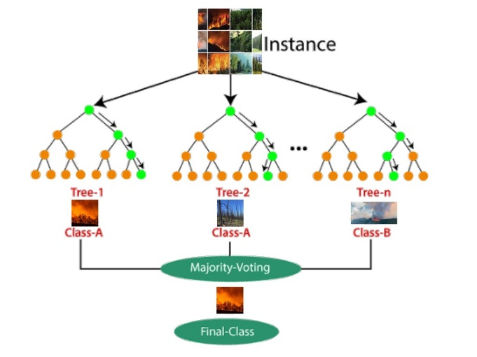

Figure 7 Detailed diagram of Random Forest tree

### 

## *3.4.3 Support Vector Machine*

Support Vector Machine (SVM) is a supervised machine learning algorithm which works efficiently for image classification. It is useful for both regression and classification purposes. The main objective of the SVM algorithm is to create a line or hyperplane that best segregates n-dimensional space, so in the future, we can easily put new data points in the right category. This best decision boundary is called a hyperplane.

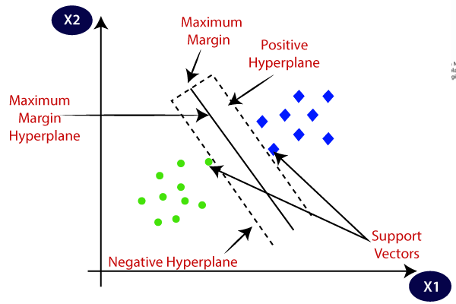

Figure 8 Schematic Diagram for SVM

## *3.4.4 ARIMA (MATHEMATICAL MODEL)*

ARIMA (Auto regressive integrated moving average), which is an efficient mathematical predictive model has been employed in R to make future forest fire analysis. Autoregressive Integrated Moving Average is a time series statistical analysis model that uses time series data, either to improve understanding of the set of data or predict future trends (Hayes, 2024).

A statistical model is autoregressive if it uses the past values in predicting the future ones. For example, an ARIMA model can predict stock prices based on a company's past performance or period-over-period foretelling of its earnings.

Figure 9 Schematic diagram of ARIMA model.

## 3.5 Application Module

Application module is followed by achieving excellent results of the trained models. This module serves the purpose of demonstrating the detection and prediction of forest fires. Streamlit written using python has been used to build the web-based application. The figure below shows how the application works. The user will be asked to create an account or log in with his existing credible credentials which will lead him to the dashboard. The dashboard comes with five tabs in the navigation bar where the home page will be displayed by default. The user can either upload or capture an image and then he can use the three models to detect the fire or no fire.

R shiny app has been integrated with the streamlit app which comes with four main features including finding fire spread rate using Rothermel model, creating a choropleth map, analyzing the Brazilian forest fires, and performing predictive analysis using ARIMA model.

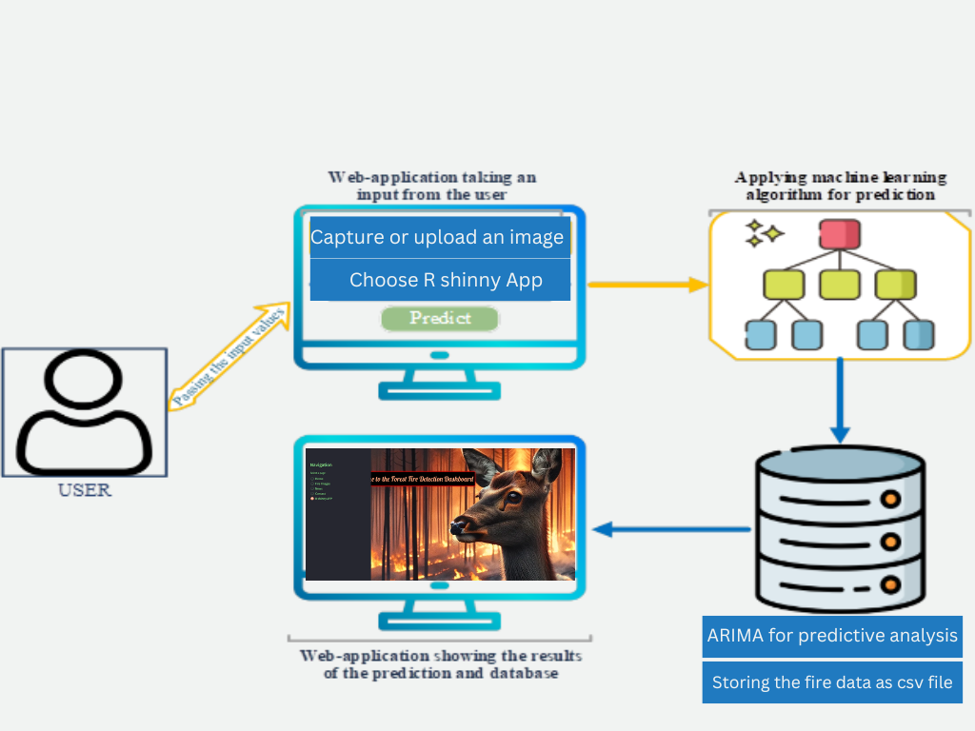

Figure 10 Illustration of web-application for prediction.

# CHAPTER 4. IMPLEMENTATION, RESULTS, AND DISCUSSION

## 4.1 Implementation Setup

The implementation setup has been discussed briefly in this section. This project has been successfully carried out in 11th Gen Intel(R) Core (TM) i7-11800H @ 2.30GHz 2.30 GHz. The programing part includes Machine learning models written in Python programing language and mathematical models deployed in R programing language. The table below shows all the specifications.

Table 4.1 Hardware and Software Specifications used in the proposed model implementations.

|  |  |  |
| --- | --- | --- |
| **Type** | **Component** | **Details and Description** |
| Hardware | Computer type  Operating System  CPU  RAM | Katana GF66 11UD  Microsoft Windows 11 Pro  Intel(R) Core (TM) i7-11800H CPU @ 2.30GHz  16.0 GB DDR2 |
| Software | PyCharm  Jupiter Notebook  Matlab R2021b  R studio | Python 3.9.7  Python 3.9.7  MATLAB  R |
| Libraries | Tensorflow  Keras  Matplotlib  NumPy  Pandas  Sklearn | Used for building of neural networks  High-level powerful API that runs on top of Theano and Microsoft Cognitive Toolkit.  Used for interactive visualizations  Used for arrays and matrices for simplifying numerical operations  Used for data analysis  Used for machine learning and statistical modeling including classification, regression, clustering and dimensionality reduction. |
| Framework | Streamlit | Python Framework for building web-application |

Table 4.2 Details of Parameters for each Classifier

|  |  |  |  |  |  |  |
| --- | --- | --- | --- | --- | --- | --- |
|  | **Algorithm** | **Parameters** | | | **Testing/Training Split** | |
| 1 | Convolutional Neural Network | **Layers** | **Units/Neurons** | **Activation** | **Batch Size** | 10 |
| Input layer (1) | 9 | ReLU | **Epochs** | 100 |
| Hidden layer (3) | 32, 64, 128 | ReLU | **Test set** | 30% |
| Drop out Layer | - | rate = 0.3 | **Train set** | 70% |
| Output layer (1) | 1 | Sigmoid | **Learning rate** | 0.5 |
| 2 | Random Forest | criterion = ‘gini’, n_estimator = 10, max_depth=10 | | | R, G, B (30,70) % | |
| 3 | SVM | kernel = ‘linear’ | | | R, G, B (30,70) % | |

## 

## 4.1. Dataset

The project revolves around image classification, the images (fire and no fire) have been taken from Kaggle. For the fire analysis, a dataset of Brazilian forest fires has been used which is from Kaggle. The ARIMA model is used for predictive analysis or forest fire prediction where the data has been retrieved from NASA FIRMS using an API. The image dataset was augmented in python to make the dataset more credible and diverse.

## 4.2. Results

In the proposed project forest fire detection and prediction has been carried out using three different machine learning models and two mathematical models. The performance of models differs from each other and fluctuates according to the changing scenarios.

*True Positives: The outcome where the model correctly predicts the positive class.*

*False Positives: The outcome where the model incorrectly predicts the positive class.*

*False Negatives: The outcome where the model incorrectly predicts the negative class.*

*True Negatives: the outcome where the model correctly predicts the negative class.*

Accuracy is a straightforward metric, representing the ratio of correct predictions to the total predictions made, essentially showing the percentage of correct predictions. Precision measures the proportion of true positives among all predicted positives. Recall, also known as the sensitivity of the model, should be reported together with precision. It calculates the proportion of true positives out of the total actual positives, combining both true positives and false negatives. A model is considered perfect when both its recall and precision are equal to 1. To balance the significance of precision and recall without biasing towards one, the F1-score is used. The F1-score is the harmonic mean of precision and recall, offering a single metric that combines the two.

The performance evaluators used are given by the equations (13-16) below:

|  |  |  |
| --- | --- | --- |
| *Accuracy* | *= $\frac{True Positives+Ture Negatives}{All Samples}$* | *(13)* |
| *Precision* | *= $\frac{True Positives}{True Positives+True Negatives}$* | *(14)* |
| *Recall* | *= $\frac{True Positives}{True Positives+False Negatives}$* | *(15)* |
| *F1-Score* | *= $\frac{2*\left(Precision*Recall\right)}{Precision+Recall}$* | *(16)* |

## 

## 

## 

## 

## 

## 

## 

## 4.2.1 Results and Discussions for Random Forest Algorithm

The project is using an image dataset where the images have been divided into training, testing, and validation dataset. These three are further divided into fire and no fire images. So, we gave training images to train the random forest model and then tested it by testing images. The model has 92% accuracy.

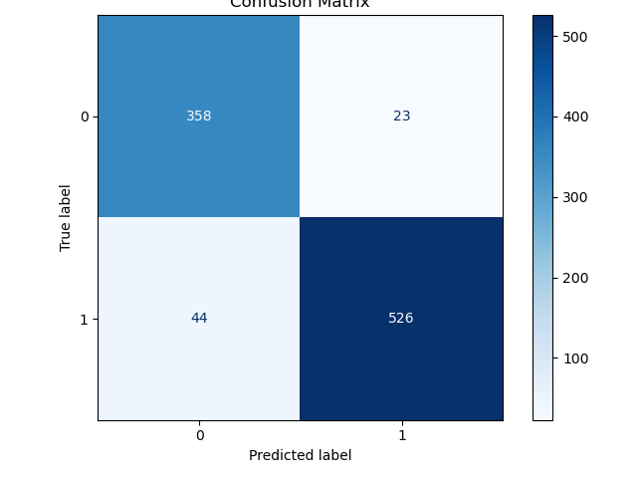

Figure 13 Fire and No Fire prediction confusion matrix using Random Forest.

The top left cell with 358 instances are true positive cases which are correctly classified as fire while 526 on the bottom right indicates the cases when the model correctly classified no fire images as no fire. The top right cell which has 23 shows false positives which mean that 23 cases were predicted incorrectly. The bottom left box with 44 instances shows false negatives which are the cases when fire images were predicted as no fire. Keeping these four factors into consideration accuracy, precision, Recall, and support has been calculated.

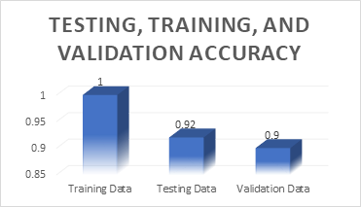

Figure 14 Accuracy of testing, training, and validation of random forest.

Figure 15 Performance evaluation of fire images (Random Forest)

Figure 16 Performance evaluation of no fire image (Random Forest)

## 

## 

## 

## 

## 

## 

## 

## 

## 

## 

## 

## 

## 

## 

## 4.2.2 Results and Discussions for Support Vector Machine

This model gives 93% accuracy.

Figure 17 Confusion matrix of SVM

The top left cell with 192 instances are true positive cases which are correctly classified as fire while 165 on the bottom right indicates the cases when the model correctly classified no fire images as no fire. The top right cell which has 0 shows false positives which mean that 0 cases were predicted incorrectly. The bottom left box with 25 instances shows false negatives which are the cases when fire images were predicted as no fire. Keeping these four factors into consideration accuracy, precision, Recall, and support has been calculated.

Figure 18 Performance evaluation of SVM.

Figure 19 Performance evaluation of fire images (SVM)

Figure 20 Performance evaluation of no fire images (SVM)

## 

## 

## 

## 

## 

## 

## 

## 

## 

## 

## 

## 

## 4.2.3. Results and Discussions for CNN

Binary convolution neural network works efficiently for image classification into two. This model is used when there are only two cases to predict. As the name suggests, convolution is the most vital part of the model which is used in the feature extraction.

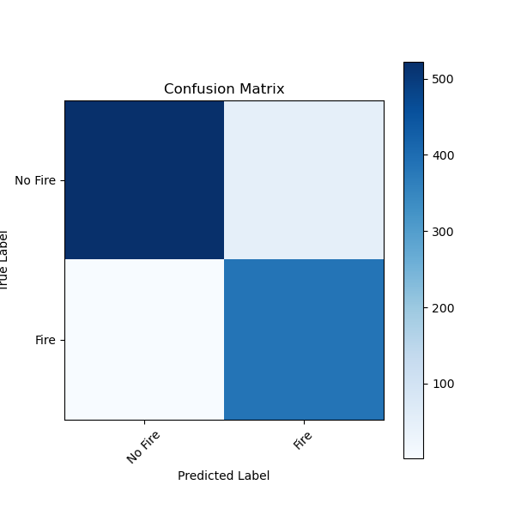

Figure 21 Confusion matrix of CNN

The top left cell with 192 instances are true positive cases which are correctly classified as fire while 165 on the bottom right indicates the cases when the model correctly classified no fire images as no fire. The top right cell which has 0 shows false positives which mean that 0 cases were predicted incorrectly. The bottom left box with 25 instances shows false negatives which are the cases when fire images were predicted as no fire. Keeping these four factors into consideration accuracy, precision, Recall, and support has been calculated.

Figure 22 Accuracy of testing, training, and validation in CNN.

Figure 23 Performance evaluation for Binary CNN

Figure 24 Performance evaluation for no fire images

## 4.2.4 Results and Discussions for Rothermel model

The Rothermel model, which is an old mathematical model, is used to find the ROS (Rate of spread) of fire. I have used R studio IDE to employ the model in R programming language. The parameters of the model depend on the environmental conditions. Heat source is the numerator while heat sink is the denominator of the model.

Figure 25 Rothermel equation.

 Reaction intensity (IR) depicts the total heat release rate per unit area of the fire front, encompassing heat that is conducted, convicted, and radiated in all directions, not solely towards the adjacent potential fuel​ (Andrews, 2018).

## 4.2.5 Results and Discussions for ARIMA model

ARIMA which stands for autoregressive integrated moving average is a widely used model for forecasting and predicting using time series. Historical data is crucial to conduct future predictions. The standard notation of ARIMA is with p, d, and q parameters where:

*P: Also known as the lag order, the number of lag observations in the model.*

*D: Also known as degree of differencing, the number of times raw observations are differenced.*

*Q: Also known as the moving average order, size of the moving average window.*

Differentiation is an integral part of ARIMA because it is used to make the data stationary. Regression model is highly impacted by a data that contains predictable and regular patterns (Hayes, 2024).

# 

# 

# 

# 

# CHAPTER 5. PERFORMANCE EVALUATION

In this section the performance evaluation of different algorithms that we have used in the proposed model has been carried out. For the performance evaluation we have used three basic metrices namely mean absolute error (MAE), mean absolute percentage error (MAPE), and root mean square error (RMSE). The formulas for performance metrics are shown below.

$MAE=\frac{ \sum_{i=1}^{n}{|y_{i}-x_{i}|}}{n}$

$MAPE=\frac{1}{n}\sum_{i=1}^{n}{\frac{|y_{i}-x_{i|}}{y_{i}}}$

and,

$RMSE=\sqrt{\frac{ \sum_{i=1}^{n}{{(y_{i}-x_{i})}^{2}}}{n}}$

We have calculated these performances measures and listed them in tables for each algorithm. We have also constructed graph of these performance metrices to better visualize the results.

Table 5.1 Evaluation metrices of RF, SVM, and CNN

|  |  |  |  |  |
| --- | --- | --- | --- | --- |
| **Statistical Meretrices** | **RMSE** |  | **MAE** | **MAPE** |
| Random Forest | 0.279 |  | 0.078 | 8.25% |
| Support Vector Machine | 69.49 |  | 48.46 | 22% |
| Binary Classification | 70.25 |  | 46.67 | 20% |

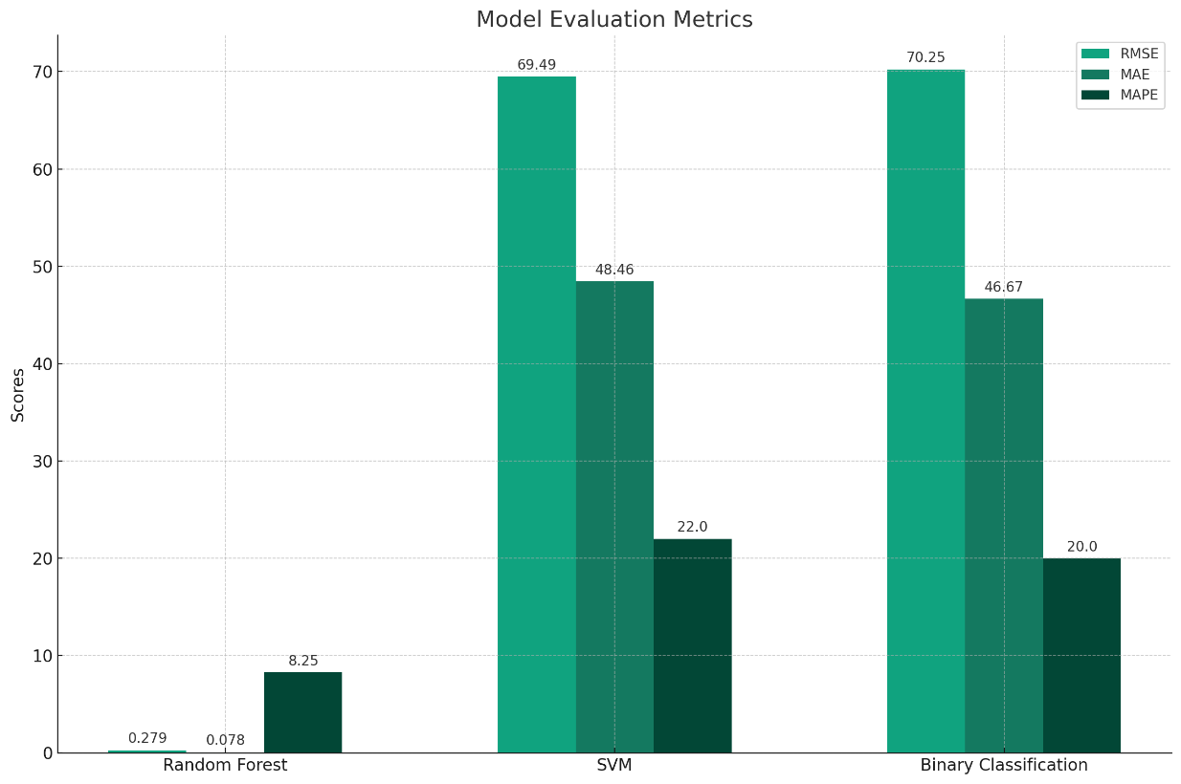

Figure 27 Graphical representation of evaluation metrices

In this section we analyzed and employed three important performance or evaluation metrics of machine learning algorithms which are RMSE, MAE, and MAPE. Here we will briefly explain which model work efficiently according to these metrices.

Among all the three models Random Forest model shows exceptionally low error rates giving higher accuracy and precision in its prediction about fire and no fire images. The values of RMSE and MAE are extremely low which indicates that the predicted values are closer to the actual values. On the other hand, the MAE and RMSE values of support vector machine are comparatively higher than the random forest which depicts a lower prediction rate. Similarly, Binary CNN gives similar results as SVM and gives a lower prediction accuracy as compared to random forest. Therefore, Random Forest is the most accurate model.

# 

# 

# 

# 

# 

# 

# CHAPTER 6. APPLICATION MODULE

The last module depicts how the project needs to be used by the users. The project has been deployed as a web application in the streamlit framework in Python and R Shinny using R. It consists of two parts such as machine learning part and mathematical part. The machine learning section consists of three trained models including SVM, RF, and Binary CNN to detect fire or no fire images either using uploaded image or captured image. On the other hand, the mathematical models include Rothermel and ARIMA model to calculate spread rate of forest fire and conduct predictive analysis respectively.

Figure 28 Homepage of the web application

The users must create an account or login with the credible credentials to access the main dashboard, where the application sends all the data to the machine learning model. Out of all machine learning models tested in this project, Random Forest algorithm gave the best results of the prediction, however, other models have been added in the main dashboard as well. Next, the algorithms make a prediction based on the received values.

.

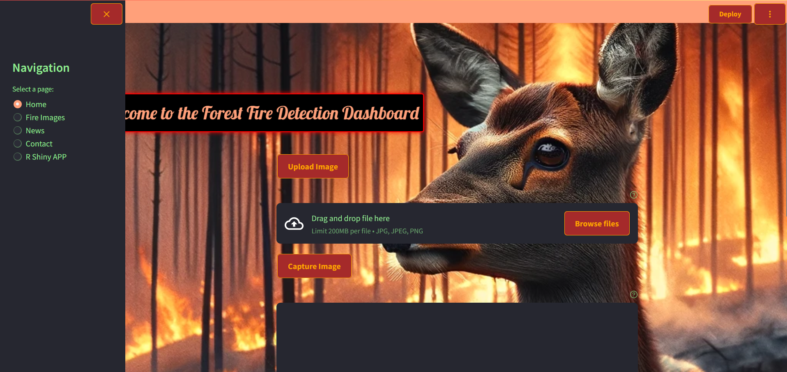

Figure 29 Dashboard page of the application

After a successful login, the user will be able to access the main dashboard which is depicted above in the figure 6.2. The vertical navigation on the left-hand side shows the main features of the web application. For the fire detection, the app gives two options either to upload an image or to capture an image. After successfully uploading or capturing the image the dashboard shows three buttons below the image labelled with the models. For instance, SVM, Random Forest, and Binary CNN. You can click on any model’s button and the result will be displayed on the screen. If it was a fire, then an alert sound will be played as well.

Figure 30 Result display after prediction

The app has two parts one is the machine learning algorithms, and another is comprised of mathematical models including rothermel for spread rate prediction and ARIMA model for doing predictive analysis. The navigation shows R shinny app feature where the mathematical models have been deployed in R programing language.

Figure 31 R Shinny dashboard

The R shinny app feature leads the user to the R shinny app whose interface looks like the above figure. The shinny app has five main features displayed vertically in the navigation bar. The features include fire spread rate, parameters, Choropleth map, forest fire analysis, and real time data. The spread rate is visualized as a 3D plot which changes with the changing parameters.

Figure 32 Detailed diagram of Rothermel model

Wind and slop factor, moisture damping, and reaction intensity are referred to as heat source and they are vital parameters to determine the spread rate. While heat sink includes effective heating, heat of pre-ignition, and effective bulk density.

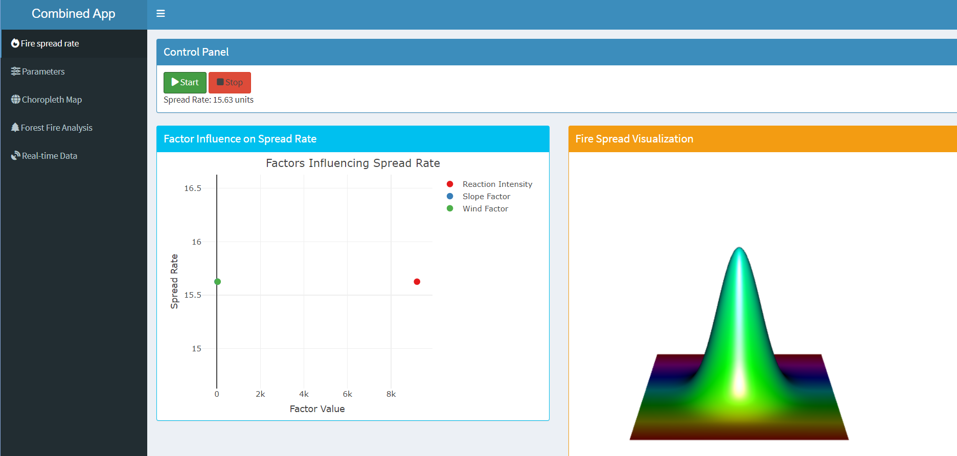

Figure 33 3D visualization of Rothermel model results

The figure above shows the 3D plot visualization of rothermel model which changes with the parameters. Higher reaction intensity, wind factor, slope factor, and moisture damping results in a higher tail of the plot.

## 

## 

## 6.1 Predictive analysis in R

Predictive analysis is a crucial step in any process because it determines the future possibilities of an event. Indeed, in forest fire scenarios, precaution and early alert is better than extinguishing the fire after its spread. R comes with an extensive variety of libraries and functions which is one of the most important benefits of it. I have gathered the data from NASA firms as a csv file which is readable by R. Following to that by using auto.arima() function the data has been used to conduct predictions. The results are shown below.

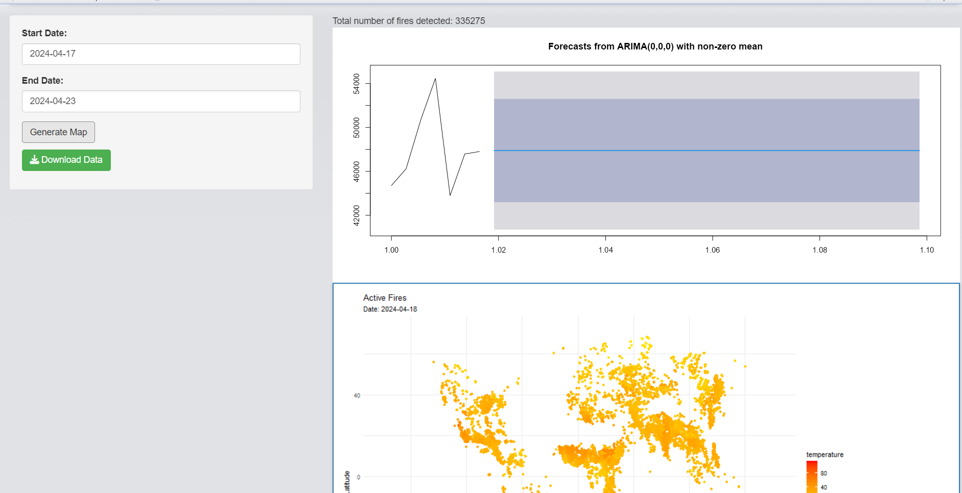

Figure 34 Forest Fires predictive analysis results

I extracted the fire data of Kyrgyzstan using NASA FIRMS and surprisingly through the satellites 1880 forest fires have been recorded in Kyrgyzstan in year 2021. This data includes both major and minor fires.

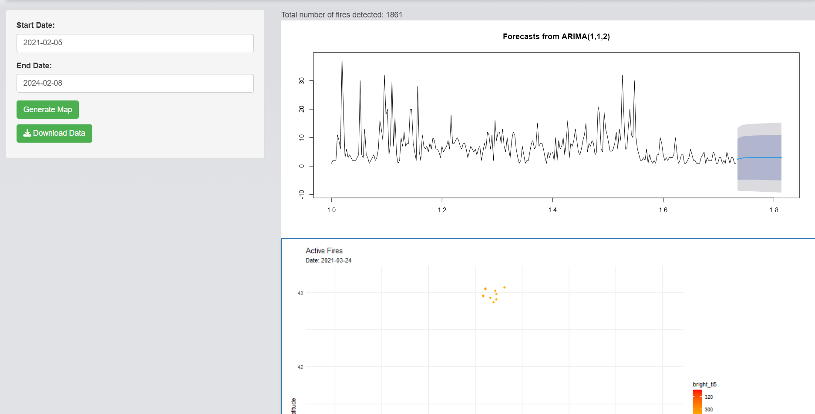

Figure 35 Forest Fires predictive analysis of Kyrgyzstan results

## 6.2 Similar applications comparison table

In an increasingly app-driven world, the marketplace teems with a multitude of applications, each vying for user attention and market dominance. Amidst this digital landscape, it becomes imperative to juxtapose similar apps, not only to discern their unique features and functionalities but also to understand how they meet different user needs or preferences. Whether it's for task management, fitness tracking, social networking, or productivity enhancement, a comparative analysis sheds light on the competitive edge of each app and highlights the innovations driving user engagement. As we delve into this comparison, we aim to unravel the nuances that set these applications apart, offering insights into their design, user experience, and overall performance. This exploration not only guides potential users in making informed decisions but also inspires developers to continuously enhance and differentiate their offerings in the crowded app ecosystem.

Table 6.2 Similar app comparison table

|  |  |  |  |  |  |  |  |  |
| --- | --- | --- | --- | --- | --- | --- | --- | --- |
| Applications  Features | Firesmoke detection app | Firealarm inspection app | DRYAD | Fireangel connected app | Smoke detector inspection app | Nimbus | Your app | Total |
| Push notifications |  | Checkbox Checked outline | Checkbox Checked outline | Checkbox Checked outline | Checkbox Checked outline |  | Checkbox Checked outline | 5 |
| Detect both smoke and fire | Checkbox Checked outline |  | Checkbox Checked outline |  |  |  | Checkbox Checked outline | 3 |
| Using mathematical models |  |  |  |  |  |  | Checkbox Checked outline | 1 |
| send daily inspection reports |  | Checkbox Checked outline |  |  |  | Checkbox Checked outline | Checkbox Checked outline | 3 |
| Classifies the fire as severe, mild, and moderate |  |  |  |  |  |  | Checkbox Checked outline | 1 |

# 6.2 Unique Features of my app

One of the features which makes my app unique is using mathematical models (Rothermel model) to predict the forest fires using real time data from the NASA FIRMS. The ARIMA (Autoregressive Integrated Moving Average) prediction model has been used to predict forest fires using the respective data. The Rothermel model finds the spread rate of fire using the given data and produces a choropleth map for it. Mathematical models are highly efficient in prediction related projects therefore, I chose them.

# 

# 

# 

# 

# 

# 

# 

# 

# 

# 

# 

# 

# 

# 

# Conclusion

In conclusion, this project on "Detecting Forest Fires using Machine Learning models and conducting predictive analysis employing Mathematical models" represents my concerted effort to leverage the cutting-edge realms of machine learning and mathematical modeling to confront a pressing environmental crisis. The foundation of this work was built on the synthesis of Binary Convolution Neural Network, Random Forest Tree, Support Vector Machine, and ARIMA models to refine the accuracy and reliability of forest fire prediction and detection mechanisms.

The endeavor was not just about algorithmic implementation but also about harnessing these technologies to make a tangible difference in forest management and disaster mitigation practices. The empirical results underscored not only the viability but also the potency of integrating technological innovations into ecological conservation efforts. This project underscores the transformative potential of machine learning and predictive analytics in crafting early warning systems and enabling proactive approaches towards forest fires, thereby aiming to reduce their adverse effects on natural habitats, human welfare, and the global climate.

Moreover, the creation of a web-based application module as an integral component of this research underscores the practical applicability of the theoretical insights garnered. This tool, which incorporates the Rothermel model for assessing fire spread and the ARIMA model for future fire incidence predictions, symbolizes a significant stride towards employing digital solutions in ecological preservation and disaster readiness.

As the global community grapples with the escalating challenges of forest fires in the wake of climate change, this project embodies the crucial intersection of computer science and environmental science. It aims to contribute valuable knowledge and tools to the academic, scientific, and practical domains concerned with forest fire dynamics.

Ultimately, this research is a testament to the belief in the power of technology to address complex environmental challenges. By contributing both to scholarly discourse and providing pragmatic tools for real-world application, this project endeavors to pave the way for more sustainable environmental management practices and a more resilient future in the face of escalating forest fire risks.

# References

A, M. (2018, April 27). Wildland fires detection and segmentation using deep learning. *Journal of applied remote sensing, 10649*, 12-26. doi:https://doi.org/10.1117/12.2304936

Abdusalomov et al. (2023). An Improved Forest Fire Detection Method Based on the Detectron2 Model and a Deep Learning Approach. *Sensors, 23*(3), 20-45. doi:https://doi.org/10.3390/s23031512

Abdusalomov, A. B. (2023). An Improved Forest Fire Detection Method Based on the Detectron2 Model and a Deep Learning Approach. *Sensors, 23*(3). doi:https://doi.org/10.3390/s23031512

Alkhatib, R. (2023, July 13). A Brief Review of Machine Learning Algorithms in Forest Fires Science. *Appl. Sci*. doi:https://doi.org/10.3390/app13148275

Benzekri, W. (2020). Early Forest Fire Detection System using Wireless. *International Journal of Advanced Computer Science and Applications, 11*(5), 1-8. Retrieved from https://pdfs.semanticscholar.org/fca3/1181e24a3148661e20d4e20d81ac9b06a426.pdf

*Cambridge reference*. (n.d.). Retrieved from https://dictionary.cambridge.org/: https://dictionary.cambridge.org/dictionary/english/forest-fire

Dampage, U. (2022). Forest fire detection system using wireless sensor networks and machine learning. *Scientific Reports*. doi:https://doi.org/10.1038/s41598-021-03882-9

Elshewey, A. M. (2020). Forest Fires Detection Using Machine. *Journal of Xi'an University of Architecture & Technology, 8*(9), 1-8. Retrieved from https://www.researchgate.net/profile/Amira-Elsonbaty-2/publication/344462171_Forest_Fires_Detection_Using_Machine_Learning_Techniques/links/5f78c3f6299bf1b53e0c1c1e/Forest-Fires-Detection-Using-Machine-Learning-Techniques.pdf

Fan, R. (2021). Lightweight Forest Fire Detection Based on Deep Learning. *IEEE*, 1-6. doi:10.1109/MLSP52302.2021.9596409

firelab. (2023, March 3). *The Rothermel Fire Spread Model: A 50-year milestone in fire research.* Rocky Mountain Research Station. firelab. Retrieved from https://www.firelab.org/news/rothermel-fire-spread-model-50-year-milestone-fire-research

Hayes, A. (2024, February 23). Autoregressive Integrated Moving Average (ARIMA) Prediction Model. *Investopedia*, 1-5. Retrieved from https://www.investopedia.com/terms/a/autoregressive-integrated-moving-average-arima.asp#:~:text=An%20autoregressive%20integrated%20moving%20average%2C%20or%20ARIMA%2C%20is%20a%20statistical,values%20based%20on%20past%20values.

Joosse, T. (2020, December 8). Human-sparked wildfires are more destructive than those caused by nature. *Science*, 1-9. doi:10.1126/science.abg0529

Kanga, Y. (2022, November 16). A deep learning model using geostationary satellite data for forest fire detection with reduced detection latency. *GIScience & Remote Sensing, 59*(1), 2019-2035 . doi:https://doi.org/10.1080/15481603.2022.2143872

Khan, A. (2022, April 28). DeepFire: A Novel Dataset and Deep Transfer Learning Benchmark for Forest Fire Detection. *Hindawi*. doi:h10.1155/2022/5358359

Kinaneva, D. (2019, May 20). Early Forest Fire Detection Using Drones and Artificial Intelligence. *MIPRO*, 1060-1065. doi:https://doi.org/10.23919/MIPRO.2019.8756696

KUKUK, S. B. (2021, July). Comprehensive Analysis of Forest Fire Detection using Deep Learning Models and Conventional Machine Learning Algorithms. *International Journal of computational and experimental science and engineering, 7*(2), 84-94. doi:https://doi.org/10.22399/ijcesen.950045

MacCarthy et al. (2023, August 29). *The Latest Data Confirms: Forest Fires Are Getting Worse*. Retrieved from world resource institute: https://www.wri.org/insights/global-trends-forest-fires

Peng, Y. (2019, December). Real-time forest smoke detection using hand-designed features and deep learning. *Computers and Electronics in Agriculture, 167*. doi:https://doi.org/10.1016/j.compag.2019.105029

Pragati. (2020). FOREST FIRE DETECTION USING MACHINE LEARNING. *INTERNATIONAL JOURNAL OF ADVANCE SCIENTIFIC RESEARCH, 4*(12), 1-7.

priya, R. S. (2019). Deep Learning Based Forest Fire Classification and Detection in Satellite Images. 61-65. doi:10.1109/ICoAC48765.2019.246817

Qingjie, Z. (2016, January ). Deep Convolutional Neural Networks for Forest Fire Detection. *Springer nature*. doi:https://doi.org/10.2991/ifmeita-16.2016.105

Rajan et al. (2022, Januray 12). FOREST FIRE DETECTION USING MACHINE LEARNING. 1-10. Retrieved from https://www.researchgate.net/publication/357811123_FOREST_FIRE_DETECTION_USING_MACHINE_LEARNING

Rajan, G. V. (2022, January ). FOREST FIRE DETECTION USING MACHINE LEARNING. Retrieved from https://www.researchgate.net/publication/357811123_FOREST_FIRE_DETECTION_USING_MACHINE_LEARNING

Sathishkumar et al. (2023, February 17). Forest fire and smoke detection using deep learning-based learning without forgetting. *Fire Ecology, 19*(9), 12-27. doi:https://doi.org/10.1186/s42408-022-00165-0

Sathishkumar, V. E. (2023). Forest fire and smoke detection using deep learning-based learning without forgetting. *Fire Ecology, 9*, 12-78. doi:https://doi.org/10.1186/s42408-022-00165-0

Seydi et al. (2022, February 21). Fire-Net: A Deep Learning Framework for Active Forest Fire Detection. *Journal of sensors, 2022*, 24-70. doi:https://doi.org/10.1155/2022/8044390

Seydi, S. T. (2022). Fire-Net: A Deep Learning Framework for Active Forest Fire Detection. *Hindawi*. doi:https://doi.org/10.1155/2022/8044390

Sobha, P. (2023, July). A Survey of the Machine Learning Models for Forest Fire Prediction and Detection. *International Journal of Communications, Network and System Sciences, 16*(7). doi:https://doi.org/10.4236/ijcns.2023.167010

*WHO*. (n.d.). Retrieved from World Health organization: https://www.who.int/health-topics/wildfires#tab=tab_1

Xu, R. (2021). A Forest Fire Detection System Based on Ensemble Learning. *Forests, 12*(2). doi:https://doi.org/10.3390/f12020217